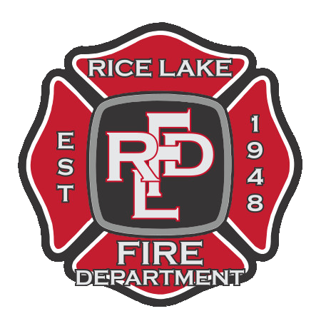

**City of Rice Lake Fire Department**

4051 Martin Road Rice Lake, MN 55803

(218) 728-1315

**Volunteer Firefighter Application Packet**

Dear Applicant,

Thank you for your interest in the position of Volunteer Firefighter with the Rice Lake Fire Department. This packet contains all of the information regarding our hiring process, the job duties of a Volunteer Firefighter, and the required application materials. The Rice Lake Fire Department is glad that you have pursued this opportunity and we want to help you become successful. If you have any questions about the material included in this packet or general concerns, please contact Fire Chief Mark Niemi.

Thank you for answering the call,

Mark Niemi

Fire Chief

(218) 491-1115

[ricelake169@gmail.com](mailto:ricelake169@gmail.com)

Volunteer Firefighter Application Packet – Updated 2017

**POSITION TITLE:**

Volunteer Firefighter – First Responder

**GENERAL DUTY STATEMENT:**

Performs protective services work by preventing and responding to emergency situations. Under the direction of a supervisor, administers life and property saving actions. Maintains fire department equipment, apparatus, facilities, and property. Work involves frequent strenuous physical involvement. Performs other related duties and responsibilities as assigned. This position is unscheduled and will have varying hours and days as required. Commits to the ongoing training and progression of the Fire Department and its Mission, Values, and Beliefs.

**COMPENSATION:**

* After 1-year of service and successful completion of your probationary requirements, you will be accepted into the Rice Lake Fire Department’s Relief Association via PERA’s Statewide Volunteer Firefighter Retirement Plan.
* Current benefit level is $2,800 per year of good service. Fully vested after 20 years, partially vested beginning after 5 years of good service.

**OVERSEEING POSITION:**

* Commanding Officer (Lieutenant, Captain, Chief, or their designee)

**POSITIONS SUPERVISED:**

* None

**MINIMUM REQUIREMENTS:**

* H.S. Diploma or GED equivalent.
* Must be at least eighteen (18) years of age.
* Must possess and maintain a valid Minnesota Driver’s License and provide a driving record at time of completed application.
* Reside within a 10-minute drive-time response to Rice Lake Fire Station 1 determined by Google Maps.
* Successful Completion of Physical Abilities Exam

**DESIREABLE QUALIFICATIONS:**

* EMS certification (Emergency Medical Responder, Emergency Medical Technician or Paramedic).
* Firefighting experience.
* Minnesota Fire Service Certification Board certifications (Including FFI, FFII, Fire Apparatus Operator, Fire Officer, Fire Instructor, Fire Inspector, Hazmat Operations, Hazmat Technician, etc.).
* Excellent physical condition.
* MN Class A or Class B Driver’s License.
* 2 year Associate Degree in Fire Science or related field.

**KNOWLEDGE, SKILLS AND ABILITIES:**

* Knowledge of relevant equipment, policies, procedures, and strategies to promote effective local emergency operations for the protection of life and property.
* Knowledge of principles and processes for providing exceptional customer service.
* Knowledge of driver safety and the importance of maintaining a safe driving record.
* Use logic and reasoning to identify the strengths and weaknesses of alternative solutions, conclusions or approaches to problems.
* Adjust actions in relation to a changing problem and others’ actions in a high stress environment.
* Watching gauges, dials, or other indicators to make sure a device is working properly.
* Monitoring/Assessing performance of yourself and others to make improvements or take corrective action.
* Actively looking for ways to help others.
* Teaching others how to do something well.
* Considering the relative costs and benefits of potential actions to choose appropriately.
* Selecting and using training/instructional methods and procedures appropriately.
* Ability to manage one’s own time effectively.
* Ability to follow verbal and written instructions.
* Ability to communicate effectively orally and in writing.
* Ability to establish effective working relationships with staff members, other agencies, and the general public.
* Ability to think and act effectively in emergency situations compounded with intense stress and physical exertion.
* Ability to quickly respond and recognize a situation that is likely to go wrong.
* Ability to apply general rules to specific problem to produce effective answers and solutions.

**EDUCATION AND EXPERIENCE:**

H.S. Diploma or GED equivalent. Post-secondary education no required. However, experience and/or professional certifications and achievements will be taken into consideration when determining successful candidates.

**EQUIPMENT AND TOOLS USED:**

Standard equipment used in this position includes but is not limited to: firefighting and emergency medical equipment including automatic external defibrillator (AED), hydraulic equipment, electric and air-operated rescue tools, SCBA, fire apparatus, fire pumps, hoses, ladders, radios, pagers, gas meters, thermal imaging cameras, computers, phones, and cleaning/maintenance equipment.

**PHYSICAL REQUIRMENTS:**

We encourage all candidates to be in good physical condition because firefighting is incredibly physically demanding, it is highly recommended candidates have excellent cardiovascular fitness, upper body strength and endurance abilities for this career.

**GENERAL COMPETENCIES AND CULTURAL FIT:**

The Rice Lake Fire Department prides itself in being there to answer our communities call in a time of need. The fire and medical service is a dynamic and ever-changing environment; therefore, training and education is a major part of your time as a member of the Rice Lake Fire Department. It is important that you understand this and are willing to take on that responsibility. As a family environment, it is also extremely important that you are supported by a strong network in your personal life. The commitment and dedication required to this service is unparalleled. While we do not profile for a typical firefighter candidate, there are characteristics that will benefit you throughout this process. The successful candidate is rooted in the community and typically works another full-time occupation. The successful candidate is physically fit and is committed to his or her personal health. The successful candidate is driven, trustworthy, honest, committed, loyal, helpful, friendly, joyful, respectful, courageous, brave, self-motivated, calm, dependable, sensitive, humble, empathetic, a team player and a hard worker. The Department does not discriminate against age, nor gender or race. While a member of the Department, all personnel shall maintain a clean and professional appearance to meet or exceed OSHA standards.

**SPECIAL REQUIREMENTS:**

Convictions for felony offense and/or misdemeanor charges will be taken into consideration when determining successful candidates. Any convictions will not automatically disqualify any candidate from consideration.

**REQUIREMENTS AFTER ACCEPTANCE:**

* Serve a minimum of one year probationary period.
* Attend all meetings within your probationary period (typically one year). May make up missed meetings with prior approval.
* Attend all trainings held at Rice Lake unless prior absence notification is approved by Chief, Asst. Chief, or Training Officer. Drill must then be made up.
* Complete FF1 and FF2 training within the first year. (Paid for by the department)
* Complete at minimum EMR medical training within the first 2 years (EMR paid by department).
* Complete radio communications class.
* Attend the majority of extra functions, public community events, the department takes part in during the first year.
* Have a working knowledge of Departmental SOP/SOG’s.
* Understand how to operate and drive all fire department apparatus, Captain will report competency to Chief staff for check off.
* Know where all equipment is located on all trucks.
* Respond to as many calls as possible. This is why we are here. Department bylaws indicate certain call volume percentages that must be attained.



**Application for Employment**

**Position Applying For: ____________________**

**Email Address: __________________________**

**Date: __________________________________**

**Last Name: _____________________________**

**First Name: ____________________________**

**Middle Name**: __________________________

**Social Security Number:** ___________________

**Driver’s License Number** __________________

**State:** ___________ **Class:** ______________

**Address:** _______________________________

**City / State / Zip:** ________________________

**Phone:** _________________________________

**Are you over age of 18?** ___________________

**Education:** Did you graduate from high school or receive a GED? _______________________________

What School did you attend? _____________________________________________________________

**College / Post-Secondary Education:**

**Name: Area of Study: Certificate / Degree:**

**______________________________________________________________________________________________________________________________________________________________________________________________________________________________________________________________________________________________________________________________________________________________________________________________________________________________________________________________________________________________________________________________**

**Employment History**

**Current** **Employer:** _______________________ **Title:** ____________________ **Years/Months**: ________

**Address:** ___________________________________**City/State/Zip:** _____________ **Phone:** __________

**Previous** **Employer:** ______________________ **Title:** ____________________ **Years/Months**: ________

**Address:** ___________________________________**City/State/Zip:** _____________ **Phone:** __________

**Previous** **Employer:** ______________________ **Title:** ____________________ **Years/Months**: ________

**Address:** ___________________________________**City/State/Zip:** _____________ **Phone:** __________

**Previous** **Employer:** ______________________ **Title:** ____________________ **Years/Months**: ________

**Address:** ___________________________________**City/State/Zip:** _____________ **Phone:** __________

**Please list relevant current professional memberships, registrations, or licenses. Include copies of certificates or licenses with your application.**

____________________________________________________________________________________________________________________________________________________________________________________________________________________________________________________________________________________________________________________________________________________

**Volunteer Experience:**

____________________________________________________________________________________________________________________________________________________________________________________________________________________________________________________________________________________________________________________________________________________

**Hobbies, trades, additional experience and training:**

____________________________________________________________________________________________________________________________________________________________________________________________________________________________________________________________________________________________________________________________________________________

**Did you serve in the military service of this country under honorable conditions from any branch of the armed forces of the US? If yes, please describe your duties and any special training.**

___________________________________________________________________________________________________________________________________________________________________________________________________________________________________________________________________________________________________________________________________________________________________________________________________________________________________________________________________________________________________________________________________________________________________________________________________________________

**References:** Please list up to five people other than relatives who can be contacted regarding your qualifications, work habits, and character.

**Name: Occupation: Phone: Job Title:**



Rice Lake Fire Department does not discriminate on the basis of handicapped status in the admission or access to, or treatment, or employment in, its programs or activities.

**SIGNATURE**

The Rice Lake Fire Department has the right to verify information provided in this application. I may be discharged from the application process if there are any misrepresentations on this application or any made by me in the interview which may be discovered now or anytime in the future.

In connection with this application for employment, I authorize the Rice Lake Fire Department and any agent acting on its behalf to conduct any inquiry into any job-related information contained in this application, including, but not limited to, my records maintained by an educational institution relating to academic performance such as transcripts. Moreover, I hereby release the Rice Lake Fire Department and any agent acting on its behalf from any and all liability of whatsoever nature by reason of requesting such information from any person.

I declare that any statement in this application or information provided is true and complete and hereby acknowledge that with my signature below.

Date: ______________________ Signature: _________________________________________________

*(Do Not Print)*

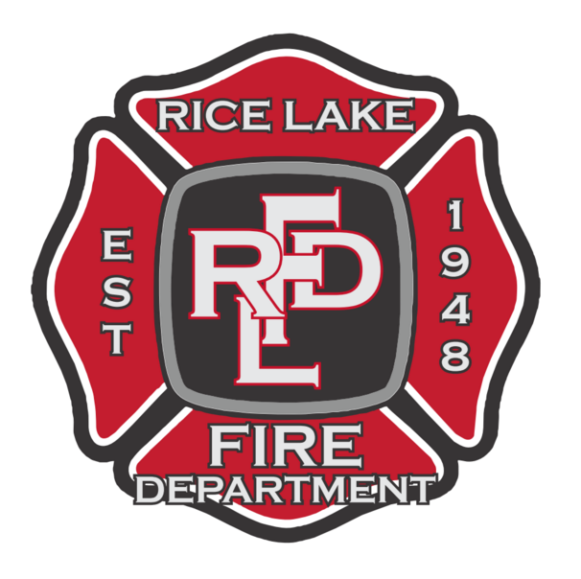

**City of Rice Lake Fire Department**

4051 Martin Road Rice Lake, MN 55803

(Hall) 218-728-1315

Fire Chief - Mark Niemi

(Cell) 218-491-1115

ricelake169@gmail.com

Date: _______________________

The following named individual has made application with this agency for employment.

Last Name of Applicant (please print): ________________________________________

First Name (please print): __________________________________________________

Middle (Full) (please print): ___________________________________________________

Maiden, Alias or Former (please print): _________________________________________

Date of Birth: _______________________ Sex (M or F): _____________

Month/Day/Year

I authorize the St. Louis County Sheriff’s Department to disclose and release all private, juvenile, and/or criminal history record information pursuant to Minnesota State Statutes §299F.035 to Rice Lake Fire Department for the purpose of employment with this agency.

The expiration of this authorization shall be one year from the date of my signature.

Signature of Applicant _____________________________ Date ____________



**City of Rice Lake**

**Waiver for Physical Ability Testing**

I acknowledge that there are risks in performing the physical ability tests that are part of the selection process for the position of volunteer fire firefighter. I understand that it is necessary for me to undergo vigorous and strenuous physical events, but my participation is voluntary.

* I agree to hold the City of Rice Lake and its employees and agents harmless if personal injury or illness, or aggravation of any prior existing condition, is suffered by me as a result of participating in the physical ability test.
* I waive the right to make any claims or lawsuits against the city or its employees or agents for any injuries or damages related to my participation in these tests.
* I understand that it is my responsibility to immediately report any injuries to the physical ability test facilitator.

This waiver does not apply to any injuries that are the result of any willful, wanton, or intentional misconduct of the city or its employees or agents.

My participation in these tests is voluntary and I understand the effect of this waiver on my legal rights.

Date: ___________________________ Name: __________________________

(Please print)

Address: ___________________________

___________________________

Signature: __________________________